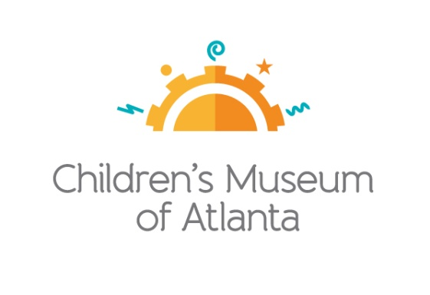

CONTACT
Becca Meyer/Jennifer Walker
BRAVE Public Relations
404.233.3993
bmeyer@bravepublicrelations.com/
jwalker@bravepublicrelations.com

*MEDIA ADVISORY*
Children’s Museum of Atlanta debuts Sockefeller Plaza for the holiday season!
Little ones invited to slip and slide on sock-only skating rink beginning November 30
ATLANTA (November 21, 2017) – Families can escape the cold weather and get into the holiday spirit with a visit to Sockefeller Plaza at Children’s Museum of Atlanta! Starting Thursday, November 30, future Olympic medalists can perfect their sock-skating skills on the ice-like surface or meet Professor Labcoat at the rink during the Super Spectacular Science Show to learn more about the forces, angles and science behind skating.

Little ones will also have the opportunity to meet and sip hot cocoa with Sid the Science Kid at the rink from 1:30-2:30 p.m. on December 4, 11 and 18!

WHAT: Sockefeller Plaza
Kids can slip and slide across the indoor sock skating rink

WHEN: November 30 – January 2

WHERE: Children’s Museum of Atlanta
275 Centennial Olympic Park Drive, NW
Atlanta, GA 30313

HOW: Access to Sockefeller Plaza, as well as the Museum’s six other permanent exhibits, is included with Museum admission. Please visit childrensmuseumatlanta.org for pricing.

For more information or to support Children's Museum of Atlanta, visit childrensmuseumatlanta.org
or call 404.659.KIDS [5437]

###

